

Maximise DM Validation

Technical Guide

**Table of Contents**

1. Introduction 1

1.1 Purpose 1

1.2 Scope and Application 1

2. Overview 1

2.1. About Maximise Validation Reports (Maximise DM) 1

2.2. Configuration 1

3. Executing Validation Process: A Step-by-Step Guide 3

Consider the following steps when performing the validation process. 3

4. Validation Phase Snippets 4

5. Maximise Technical Specification 5

5.1. Finance 5

5.2. SCM 5

Version Control

|  |  |  |
| --- | --- | --- |
| Date | Version | Created By |
| 20/12/2023 | 0.1 | Sinchana Ramesh / Shaik Latheef |

Circulation List

|  |  |
| --- | --- |
| Name | Organisation/Title |
|  |  |
|  |  |

Reference Documents

|  |  |  |
| --- | --- | --- |
| Title | Description | Owner |
|  |  |  |

# 1. Introduction

## 1.1 Purpose

This document aims to outline the process related to the recent inclusion of a new enhancement called Validation which has been added to Maximise

## 1.2 Scope and Application

This document provides the Maximise high-level summary of Validation process to Data Migration.

This document outlines the following details:

* A concise summary of Validation Reports.
* Details on the necessary configuration for the Validation process.
* An outline of the steps involved in performing Validation.
* Entities in Maximise with Validation Reports.

# 2. Overview

## 2.1. About Maximise Validation Reports (Maximise DM)

Validation Reports play a crucial role in the post-extraction phase, where their primary purpose is to validate the accuracy of the extracted data. This entails verifying that the data aligns with the anticipated format, structure, and established standards. Key aspects of this validation process include checking for adherence to data types and naming conventions, as well as addressing issues like duplicates, missing values, and outliers. Additionally, an essential facet of the validation is the assessment of the extraction process's performance to ensure efficient operation without adverse impacts on the subsequent transform and load processes.

## Configuration

The following configurations must be set up for the Validation Phase.

* The installation of the tables listed below needs to be done.
* The installation process for validation tables closely mirrors that of maximise STG tables, with the distinction of incorporating an additional column, "Validation_Error_Message" to convey error messages encountered during the validation phase.
* As of now, there is no file archiving, this will be developed in future.

|  |  |  |
| --- | --- | --- |
| Business Entity | Table Name | Description |
| SUPPLIERS | XXMX_AP_SUPPLIERS_VAL | Validation Staging Table or act of staging data in a database table. |
| SUPPLIER_ADDRESSES | XXMX_AP_SUPP_ADDRS_VAL | Validation Staging Table or act of staging data in a database table. |
| SUPPLIER_SITES | XXMX_AP_SUPPLIER_SITES_VAL | Validation Staging Table or act of staging data in a database table. |
| SUPPLIER_CONTACT | XXMX_AP_SUPP_CONTACTS_VAL | Validation Staging Table or act of staging data in a database table. |
| SUPPLIER_SITE_ASSIGNS | XXMX_AP_SUPP_SITE_ASSIGNS_VAL | Validation Staging Table or act of staging data in a database table. |
| SUPPLIER_BANK_ACCOUNTS | XXMX_AP_SUPP_BANK_ACCTS_VAL | Validation Staging Table or act of staging data in a database table. |
| PURCHASE_ORDERS | XXMX_SCM_PO_HEADERS_STD_VAL  XXMX_SCM_PO_DISTRIBUTIONS_STD_VAL  XXMX_SCM_PO_LINE_LOCATIONS_STD_VAL  XXMX_SCM_PO_LINES_STD_VAL | Validation Staging Table or act of staging data in a database table. |

* Configuration of Metadata is required for specific Business Entity, Addition of three new columns will be added to the **XXMX_MIGRATION_METADATA** table.

|  |  |  |  |
| --- | --- | --- | --- |
| BUSINESS_ENTITY | VAL_PACKAGE_NAME | VAL_PROCEDURE_NAME | VAL_TABLE |
| SUPPLIERS  SUPPLIER_ADDRESSES  SUPPLIER_SITES  SUPPLIER_CONTACT  SUPPLIER_SITE_ASSIGNS  SUPPLIER_BANK_ACCOUNTS | XXMX_SUPPLIER_VALIDATIONS_PKG | VALIDATE_SUPPLIER_PROFILES  VALIDATE_SUPPLIER_ADDRESSES  VALIDATE_SUPPLIER_SITES  VALIDATE_SUPPLIER_CONTATCS  VALIDATE_SUPPLIER_SITE_ASSIGN  VALIDATE_SUPPLIER_BANK_ACCTS | XXMX_AP_SUPPLIERS_VAL  XXMX_AP_SUPP_ADDRS_VAL  XXMX_AP_SUPPLIER_SITES_VAL  XXMX_AP_SUPP_CONTACTS_VAL  XXMX_AP_SUPP_SITE_ASSIGNS_VAL  XXMX_AP_SUPP_BANK_ACCTS_VAL |
| PURCHASE_ORDERS | XXMX_PO_VALIDATIONS_PKG | VALIDATE_PO_HEADERS  VALIDATE_PO_DISTRIBUTIONS  VALIDATE_PO_LINE_LOCATIONS  VALIDATE_PO_LINES | XXMX_SCM_PO_HEADERS_STD_VAL  XXMX_SCM_PO_DISTRIBUTIONS_STD_VAL  XXMX_SCM_PO_LINE_LOCATIONS_STD_VAL  XXMX_SCM_PO_LINES_STD_VAL |

## 3. Executing Validation Process: A Step-by-Step Guide

## Consider the following steps when performing the validation process.

* The validation package follows the following naming convention.

**XXMX_SUPPLIER_VALIDATIONS_PKG** – For Suppliers.

**XXMX_PO_VALIDATIONS_PKG** – For Purchase Orders.

* Each procedure within the validation package is designed at the sub-entity level, featuring one main procedure aligned with the Business-Entity level, while the remainder of the package structure adheres to the extract package format.

|  |  |  |
| --- | --- | --- |
| Business Entity | Sub Entity | Procedure Name |
| SUPPLIERS | SUPPLIERS | XXMX_AP_SUPPLIERS_VAL |
| SUPPLIER_ADDRESSES | SUPPLIER_ADDRESSES | XXMX_AP_SUPP_ADDRS_VAL |
|  | SUPPLIER_THIRD_PARTY_RELS | XXMX_AP_SUPP_ADDRS_VAL |
| SUPPLIER_SITES | SUPPLIER_SITES | XXMX_AP_SUPPLIER_SITES_VAL |
| SUPPLIER_CONTACT | SUPPLIER_CONTACTS | XXMX_AP_SUPP_CONTACTS_VAL |
|  | SUPPLIER_CONT_ADDRS | XXMX_AP_SUPP_CONTACTS_VAL |
| SUPPLIER_SITE_ASSIGNS | SUPPLIER_SITE_ASSIGNS | XXMX_AP_SUPP_SITE_ASSIGNS_VAL |
| SUPPLIER_BANK_ACCOUNTS | SUPPLIER_BANK_ACCOUNTS | XXMX_AP_SUPP_BANK_ACCTS_VAL |
|  | SUPPLIER_PAYEES | XXMX_AP_SUPP_BANK_ACCTS_VAL |
|  | SUPPLIER_PMT_INSTRS | XXMX_AP_SUPP_BANK_ACCTS_VAL |
| PURCHASE_ORDERS | PO_HEADERS_STD | XXMX_SCM_PO_HEADERS_STD_VAL |
|  | PO_LINES_STD | XXMX_SCM_PO_DISTRIBUTIONS_STD_VAL |
|  | PO_LINE_LOCATIONS_STD | XXMX_SCM_PO_LINE_LOCATIONS_STD_VAL |
|  | PO_DISTRIBUTIONS_STD | XXMX_SCM_PO_LINES_STD_VAL |
|  |  |  |

* Validation scripts commands for execution:

**EXEC XXMX_SUPPLIER_VALIDATIONS_PKG.VALIDATE_SUPPLIERS('FIN','AP','SUPPLIERS');**

**EXEC XXMX_PO_VALIDATIONS_PKG.VALIDATE_PURCHASE_ORDERS('SCM','PO','PURCHASE_ORDERS');**

* The execution of the validation phase is currently limited to the back end using PL/SQL; however, future plans involve its development for the front end using VBCS.

# Validation Phase Snippets

* **Validation Phase for Supplier looks like below**

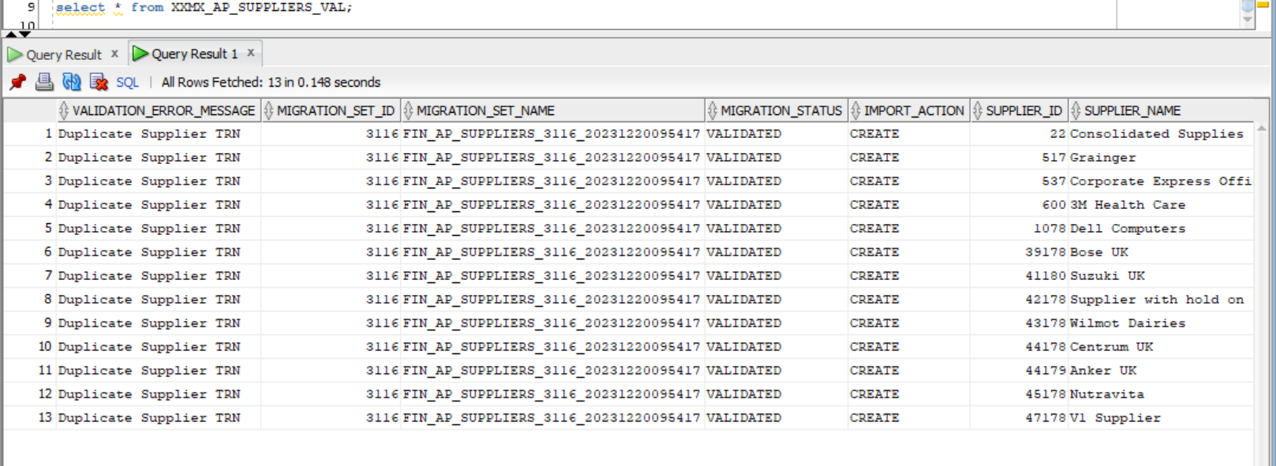

* **Validation Phase for Purchase Orders looks like below**

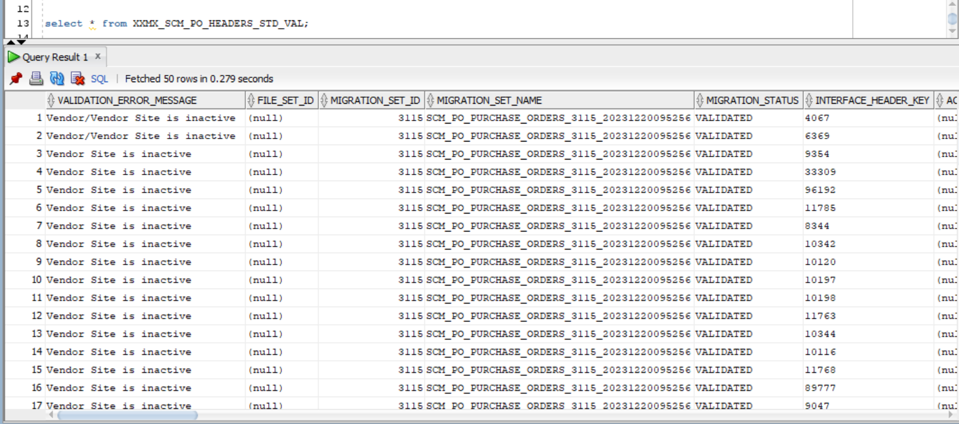

# 5. Maximise Technical Specification

This section outlines the Business Entities and Sub Entities included in Maximise DM Validation Phase as of now.

## 5.1. Finance

The table below shows a list of all business and sub-entities covered by Maximise DM for Validation.

|  |  |
| --- | --- |
| Business Entity | Sub Entity |
| Suppliers | Suppliers |
| Supplier Addresses |
| Supplier Sites |
| Supplier Third Party Relationships |
| Supplier Site Assignments |
| Supplier Contacts |
| Supplier Contact Addresses |
| Supplier Payees |
| Supplier Bank Accounts |

## 5.2. SCM

|  |  |
| --- | --- |
| Business Entity | Sub Entity |
| Purchase Orders | Headers |
| Lines |
| Line Locations |
| Distributions |





[**www.version1.com**](http://www.version1.com)

*`*